**Team 3 Opentrons Quick Instructions**

1. Create a folder on the C: drive – e.g. Opentrons_Protocols_&_Spreadsheets

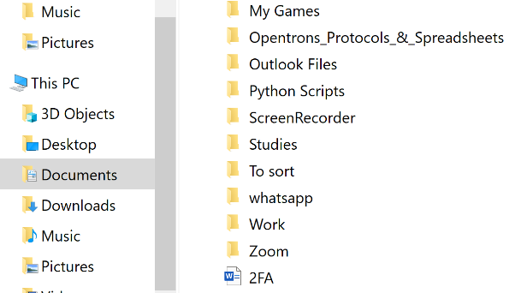

1. A picture containing text

   Description automatically generatedInsert the “Cycle_0_Protocol.py” and “Fluorescence_Data_Processing_&_New_Protocol_Generation_Scripts.ipynb” into this folder.
2. Open the Opentrons Control Program and open the “Cycle 0 – Protocol.py”. Set up the pipettes and deck as indicated and carry out calibration.
3. Run the “Cycle 0 – Protocol.py”. Upon completion, remove the “test plate” (deck location “3”) and analyse using the “Fluostar Omega Fluorescence Plate Reader”.
4. Graphical user interface, application, Word

   Description automatically generatedExport the results as an excel file (.xlsx). Insert this excel file into the folder created in step (1). Name the file as e.g. Fluorescence_Data_1.xlsx
5. Open the “Fluorescence_Data_Processing_&_New_Protocol_Generation_Scripts.ipynb” using Jupyter notebook. Run script (1).
   1. Select the excel spreadsheet, and using “shift + right click”, select “copy as path”.

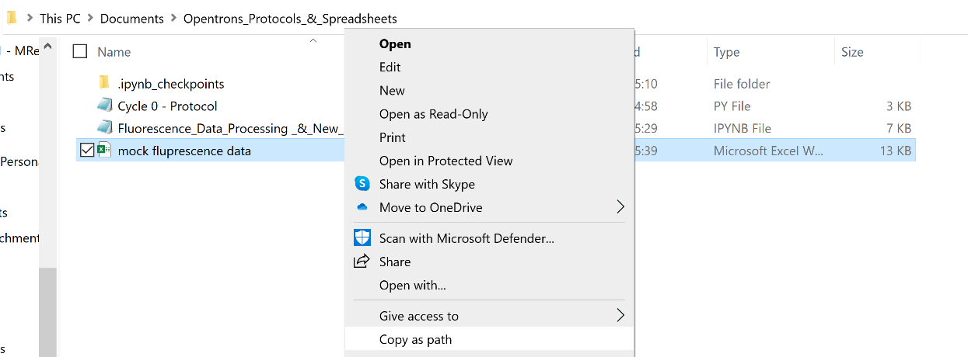

* 1. Paste this path into the user input box labelled “Please enter file path =”. Press the “enter” key.

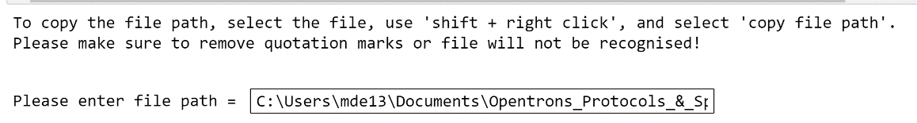

NB ensure quotation marks have been removed from the start and end of the file path, else the script will not be able to recognise the file format.

* 1. Enter the number of wells the user would like extracted into the user input box labelled “How many wells would you like to extract? (10 is advised) =”. (For this protocol, please enter 10). Press the “enter” key.

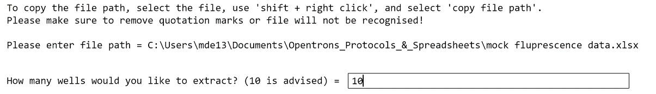

* 1. The script will print a dictionary of the 10 wells that display the highest fluorescence in the selected excel file

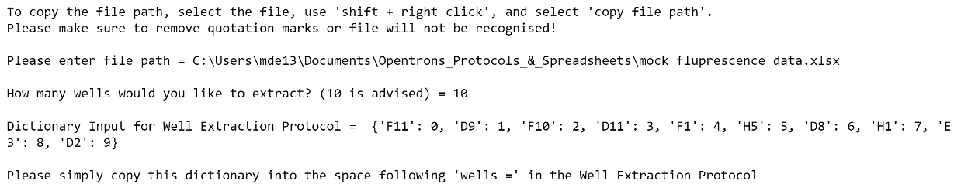

* 1. Copy this dictionary and paste it into script (2) at the indicated location.

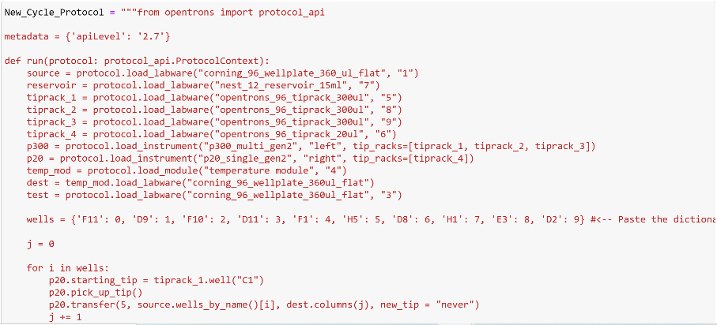

1. Graphical user interface, text, application

   Description automatically generatedHaving pasted the dictionary into script (2), run the script. An out-file titled “New_Protocol.py” will be generated containing the new protocol for the opentrons, instructing it to sample the 10 wells with highest fluorescence (creating 8 replicants of each), before carrying out the subsequent preparation steps utilised in cycle 0. Rename this file e.g. “Cycle_1_Protocol.py”
2. Restock all consumables (tips and plates) on the deck of the opentron and replenish the reagents within the reservoir on deck location “7”. Additionally:

* Remove the “dest” plate from the heating block and place on deck location “1” instead of the “source”– this plate is now the “source” for the next cycle.
* Load a new plate onto the heating block – this is the new “dest” plate for the next cycle.

1. Load and run the new protocol (“Cycle_1_Protocol.py”). Once completed, repeat steps (6)-(9) for as many cycles as required.